Exploring Linux Package Management with Command Line

**Part 1: Installation**

Ensure your system is up-to-date by running:
- sudo apt update
- sudo apt upgrade

**Part 2: Package Management Basics**

- APT (Advanced Package Tool) : it is the default package manager for Debian and its derivatives, including Ubuntu. It is used to manage software packages and their dependencies. Here's a brief overview of APT:

1. perform the following tasks:

a. Install a package : sudo apt install package_name.
Ex : sudo apt install vim
b. Update your package :
Ex : sudo apt update
c. Upgrade installed packages:
Ex : sudo apt upgrade
d. Remove a package : sudo apt remove package_name
Ex : sudo apt remove vim

**Part 3: Exploring Advanced Package Management**

2. Research and choose a Linux package manager that is different from the one native to your distribution. Examples include 'dnf' on Ubuntu or 'apt' on CentOS.

- Choosing a package manager that is different from the one native to your distribution can be done, but it's important to note that doing so may lead to compatibility issues and system instability. let's consider using ‘dnf’ on Ubuntu.
Using DNF on Ubuntu:
dnf is the package manager native to Red Hat-based distributions like Fedora and CentOS. To use dnf on ubuntu, need to install it manually.
- Install DNF : you can use the following command to install dnf in ubuntu.
- Sudo apt update
- sudo apt install dnf
2. Use DNF : Once installed,you can use DNF as you would on a Red Hat-based system. For example:
- To install a package : sudo dnf install Package_name
- To update packages : sudo dnf update
- To remove a package : sudo dnf remove Package_name
Important Considerations:
- Compatibility : Mixing package managers from different distributions can lead to conflicts and dependency issues. You might encounter errors when trying to install or update packages.
- Repository Compatibility : DNF primarily works with RPM-based repositories, and it may not have access to the same set of packages available in Ubuntu's APT repositories.
- Risk : Using an incompatible package manager can potentially disrupt your system's package management, leading to instability.

3. Install the chosen package manager on your system.
- Use DNF to Install curl: Once dnf is installed,you can use it to install curl as you would on a Red Hat-based system:
Ex : sudo dnf install curl
- To verify the Installation:
Ex : sudo curl --version
4. Perform the same tasks as in Part 2 using the alternative package manager. Observe any differences in commands and behavior.
- To install a package : sudo dnf install curl
- To update packages : sudo dnf update
- To remove a package : sudo dnf remove curl

**Part 4: Package Search**

using your distribution’s native package manager is always the safest and most reliable way to install and manage software on your linux system. For most linux distributions, the package manager is specifically designed and tested to work seamlessly with the distribution’s package repositories and libraries. This ensures compatibility and stability.

Example : sudo apt search <package_name>

sudo apt search vim

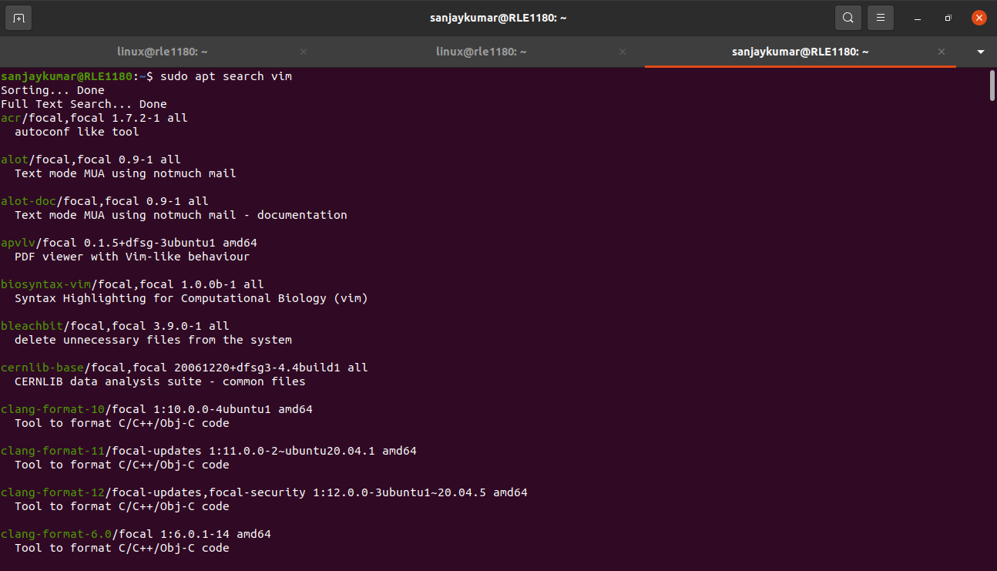
**Part 5: Documentation and Troubleshooting**

5.Explore the documentation for your distribution's package manager. Learn about additional options, flags, and configuration files.
1. apt-get and apt commands:
- ‘apt-get’ and ‘apt’ are the primary command-line tools for package management.apt is a more user-friendly alternative to apt-get.
2. Flags for apt and apt-get Commands:
- ‘-y’ or ‘—yes’ : Automatically answer “yes” to prompts.
- ‘-q’ or ‘—quiet’ : suppress output to reduce verbosity.
- ‘-f’ or ‘--fix-broken’ : Attempt to fix broken dependencies.
- --dry-run : Simulate an action without making changes.
- ‘-s’ or ‘—simulate’ : show what actions would have been taken without actually doing them.
3. Configuration Files:
- /etc/apt/sources.list : Contains the list of package repositories from which APT fetches packages.
- /etc/apt/source.list.d/ : Additional repository configuration files can be placed here.
- /etc/apt/preferences : This file is used to assign priorities to different package versions.
- /etc/apt/apt.conf and /etc/apt/apt.conf.d/ : Configuration files for custom APT settings.
- /etc/apt/apt-key.d/ : Directory for GPG keys used for package verification.

6. Attempt to troubleshoot common package management issues, such as dependency conflicts, missing keys, or broken packages. Document your troubleshooting process and solutions.
1. Update the Package List:
- ensure your package list is up to date :
sudo apt update
2.Resolve Dependency Conflicts:
- if you encounter dependency conflicts,you can try to resolve them using APT’s built in features. For example,
sudo apt-get -f install
this command attempts to fix broken dependencies.
3. Identify and fix Broken Packages:
- To identify broken packages,run :
sudo apt install -f
this will attempt to fix any broken packages and missing dependencies.
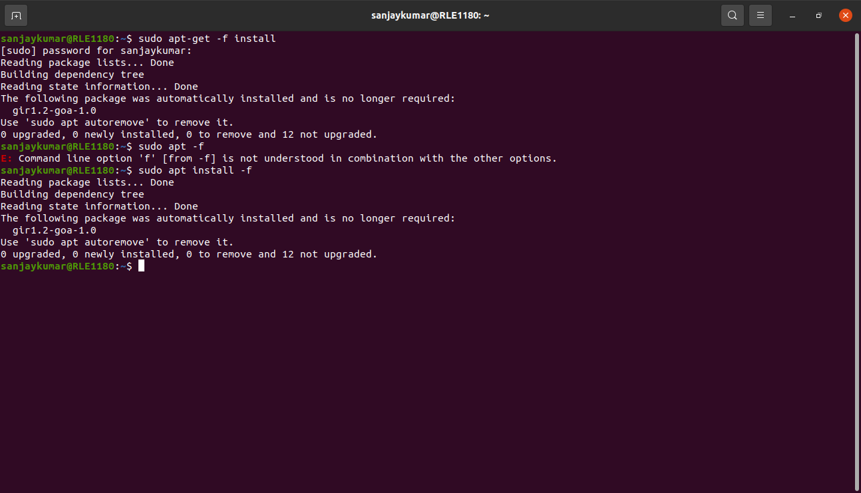
4. Missing Repository Keys:
- if you see a “NO_PUBKEY” error indicating missing repository keys,you can import the key using the key’s fingerprint. For example:
sudo apt-key adv –keyserver keyserver.ubuntu.com –recv-keys KEY_ID
Replace KEY_ID with the actual key ID.
5.Clean Local Cache:
- if you suspect that corrupted package files are causing issues,you can clean the local cache and then update:
sudo apt clean
sudo apt update
6. Check Repository URLs:
- Sometimes,issues can arise from incorrect URLs. Ensure that your etc/apt/sources.list and repository configurations are correct.

